Jana Magdy 19100913

Mariam Hossam 19100240

**MODI-SIC Project**

We used python to implement our code . The input file that contains the number lines and comments will be generated to the Intermediate file that will contain no number lines or comments .

Now that the intermediate file is ready once you run the program multiple files will be generated these files are :

* Output file : where you can see the calculated location counter
* SymTab file : where you can see all the symbols in the assembly code and their exact location
* ObjCode file : In this file you can see the assembly code with it’s location counter in addition to the object code for every instruction
* HTE file : This file contains the HTE records for the assembly code.

Our project can successfully implement any assembly code and will be able to generate Pass One and Pass Two without any problems!

**Intermediate file**

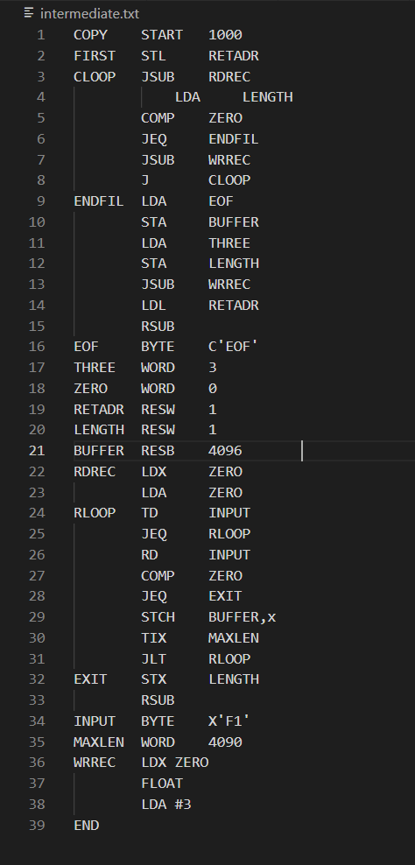

**Location Counter**

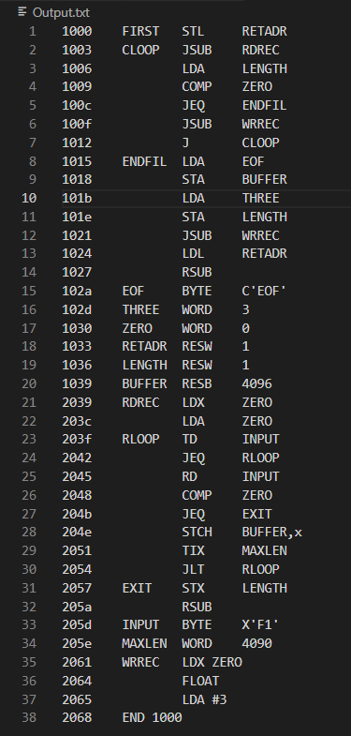

**Symbol Table:**

**Object Code:**

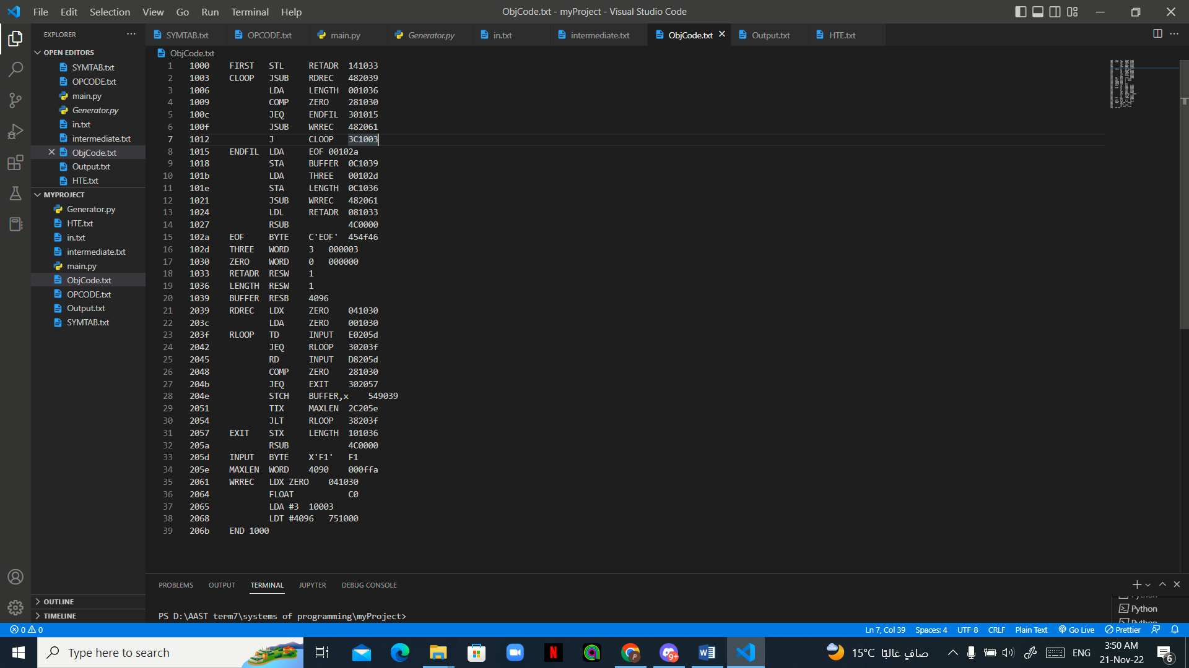

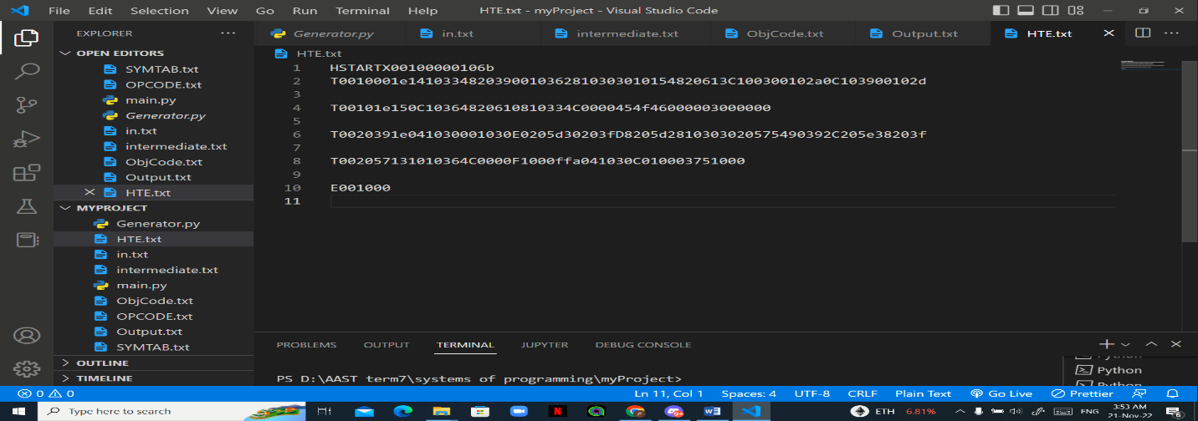**HTE Record:**